Module and Position
Home New Style 2
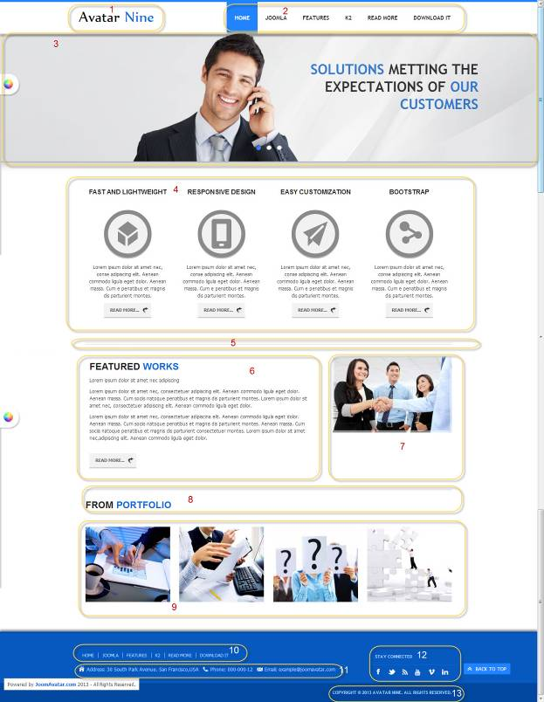

All of our templates are packed with:
- Extensions - These are modules/plugins/component to use on this template.
- Template - This is only the template install file
- Quickstart - This is your main quickstart package, it will help you to rebuild demo.
- Documentation
If this template is not downloaded directly from amazing-templates.com. Please, go to our website and download full template pakage.
This documentation file helps you build your site manualy

6. Menu item type: Single Article
Article Name: Home New Style 2
HTML source code:
<h1><span style="line-height: 1.3em; font-weight: bold;">FEATURED <span class="avatar_text_color">WORKS</span></span></h1>
<p><span style="line-height: 1.3em;">Lorem ipsum dolor sit amet nec, consectetuer adipiscina elit. Aenean commodo ligula eget dolor. Aenean massa. Cum sociis natoque penatibus et magnis dis parturient montes. Aenean massa. Cum sociis natoque penatibus et magnis dis parturient consectetuer montes. Lorem ipsum dolor sit amet nec,adipiscing elit. Aenean commodo ligula eget dolor.</span></p>
<p><a class="avatar_readmore_btn" href="#">Read more...</a></p>
<p> </p>

1.
Module Type: Custom HTML
Module Name: Logo (hide title)
Module Class Suffix: no-padding-marging avatar-template-logo
Position: Top-left

HTML source code:
<p><a href="Your Link Site "><span style="color: #000;">Your</span> Site Name</a></p>

2.
Module Type: Menu
Module Name: Main Menu
Module class suffix: _menu no-padding-marging
Menu class suffix: avatar-main-menu
Alternative layout: Responsive
Position: Top-right

3.
Module Type: Avatar Articles Nivo
Module Name: Banner Tool Home
Module Class Suffix: avatar-caption no-padding-marging avatar-banner-full
Module Postion: Tool (width of TOOL BLOCK is 100% (configuration in templates manager))

DATA
Go to Content Manager.
Creat New Category.
Create articles in category just created.
In a newly created articles, Select intro image and written content slide.
Then go to the Banner Tool Home Manager.
Select the category for slidershow.

4.
Module Type: Avatar Template Showcase
Module Name: Features Home News Style 2
Module class suffix: no-padding-marging
Module Showcase: features_1
Position: content-top
column: 4

DATA
Go to Content Manager.
Creat FEATURES_1 Category.
Create articles in category just created.
In a newly created articles, Select intro image and written content slide.
Then go to the Features Home News Style 2 Manager.
Select the category for display.

5.
Module Type: Custom HTML
Module Name : Home New Style 2 separate
Module class suffix: no no-padding-margin-tb
Position: content -top

HTML source code:
<h1 style="border-top: 4px double #dedede; line-height: 0; margin: 0;"> </h1>

7.
Module Type: Custom HTML
Module Name: ABOUT US Home new style 2
Module class suffix: no-padding-margin-tb
Position: Left-top

HTML source code:
<p><img src="images your image Link " alt="" style="margin-top: 30px; display: block; margin-left: auto; margin-right: auto;" /></p>

8.
Module Type: Custom HTML
Module Name: FROM PORTFOLIO TITLE
Module class suffix: no-padding-margin-tb
Position: content-bottom

HTML source code:
<h1 style="border-top: 4px double #dedede; padding-top: 20px;"><span style="line-height: 1.3em; font-weight: bold;">FROM <span class="avatar_text_color">PORTFOLIO</span></span></h1>
<p>This is another Alternative layout of Articles - News Flash Module</p>

9.
Module type: Avatar Template Showcase
Module name: FROM PORTFOLIO (Show title)
Module class suffix: no-padding-marging
Alternative layout: portfolio_1
Column: 4

Position: content-bottom

DATA
Go to Content Manager.
Creat WORKS Category.
Create work articles in category just created.
In a newly created articles, Select intro image and written content slide.
Then go to the FROM PORTFOLIO Manager.
Select the category for display.

10.
Module Type: Menu
Module Name: Footer Menu
Module class suffix: no-padding-margin-side
Menu class suffix: avatar-footer-nav
Alternative layout: Responsive
Position: Footer-Left

11.
Module Type: Custom HTML
Module Name: Address
Module Class Suffix: avatar-module-border-top avatar-footer-address no-padding-marging
Position: Footer -left

HTML source code:
<ul style="display: table;">
<li class="avatar-address"><span style="line-height: 1.3em;">Address: Your Address</span></li>
<li class="avatar-phone"><span style="line-height: 1.3em;">Phone: Your Phone Number</span></li>
<li class="avatar-email"><span style="line-height: 1.3em;">Email: Your email</span></li>
</ul>

12.
Module Type: Custom HTML
Module Name: STAY CONNECTED
Module Class Suffix: no-padding-margin-side social-heading
Position: Footer -right
HTML source code:
<div class="avatar-footer-social avatar-module-border-top">
<a class="facebook" href="Your Facebook Link"> </a>
<a class="twitter" href="Your Twitter Link"> </a>
<a class="feed" href="Your Feed Link"> </a>
<a class="youtube" href="Your Youtube Link"> </a>
<a class="vimeo" href="Your Vimeo Link"> </a>
<a class="linkedin" href="Your Linkedin Link"> </a>
</div>

13.
Module Type: Custom HTML
Module Name: copyright
Module Class Suffix: avatar-copyright
Position: Footer
HTML source code:
<p><a href="www.joomavatar.com">Copyright © 2013 Avatar Nine. All Rights Reserved.</a></p>

